HCI Expansion in MRCC Carmen Warehouse

DAY 1 (Setup)
Installation of Server & Switches
Server: FHQ4FEG033 & FHQ4FEG039
Switch: G1T0BCV070746 & G1T0ACV04063B

DAY 2 (Configuration of Switch (Ruijie) & Management Interface (Sangfor)
NODE 1 (FHQ4FEG039)
NODE 2 (FHQ4FEG033)
SWITCH 1 - Master (G1T0ACV04063B)
SWITCH 2 - Slave (G1T0BCV070746)

Same Subnet
Node IP – 172.23.1.50 /24
172.23.1.51 /24
Cluster IP – 172.29.1.52 /24

187 Below 240
Migration Tool – 192.168.187.28 /24
Sangfor Cloud Platform – 192.168.187.29 /24

Using Switch Console Configure Master and Slave
Reset Switch and configure through CLI
Install Firmware and reset switch through Web Based Interface
Using ETH0 port of NODES create Management Interface
DAY 3 (Switch Firmware Update & Download Sangfor HCI packages)
Download
- SCP6.11.1_EN Deployment VMA Image
- Support upgrade from older version of witness node to HCI6.11.1R1. The corresponding version must be HCI 6.11.1R1
- Fresh installation of Witness Node. The corresponding version must be HCI 6.11.1R1
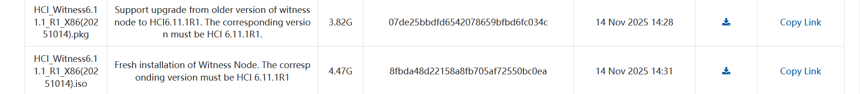

Updating firmware of Ruijie Switches
Configure Switch
Insert Connection of Ethernet Cable (CAT6)
Use Peripherals (Monitor, Mouse and Keyboard) for HCI Wittness

HCI resolves bridge skipping issues of two nodes
Connected via vlan
Must have two switches (stock setup) for redundancy
If one node faile there’s still one node to backup the connection

